20.17: For all cases,  a) The heat is discarded at a higher temperature, and a refrigerator is required;
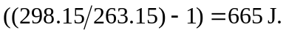 b) Again, the device is a refrigerator, and c) The device is an engine; the heat is taken form the hot reservoir, and the work done by the engine is 
